**Tic Tac Toe**

Input

1. Initially, the program asks for the number of players.

Number of players must be between 2 and 4.

If the user enters number of players, it will display Tic Tac Toe board.

1. 3x3 board for 2 players
2. 4x4 board for 3 players
3. 5x5 board for 4 players
4. After printing board, it will ask the number (Range : 1~9, 1~16 or 1~25) in which to fill pattern in board.
5. If it is player-1 turn and enter 9, it will fill **P1** in index **9** of board.
6. If it is player-2 turn and enter 5, it will fill **P2** in index **5** of board.
7. If it is player-3 turn and enter 15, it will fill **P3** in index **15** of board.
8. If it is player-4 turn and enter 23, it will fill **P4** in index **23** of board.

If the player enters invalid number, it will tell that player to enter correct index again.

Invalid number can be in three conditions.

1. Out of range numbers
2. Not a number (string or char)
3. Number that already entered by other player.

Game Win

Game will win in four conditions.

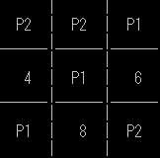 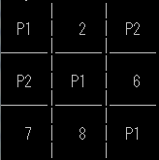 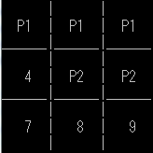 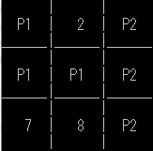

Player-1 wins Player-1 wins Player-1 wins Player-2 wins

Game Draw

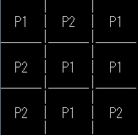

In this condition, board is filled with pattern (P1 and P2) and there is no win condition in this case.

Play Again or not

After the game finished (draw or win), you can play again or quit by entering “y” or “n”.

“y” stands to play again.

“n” stands to stop the game and exit.